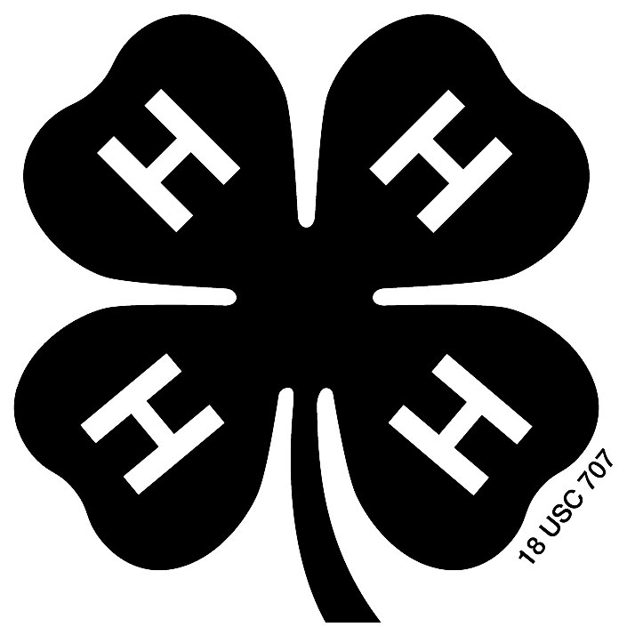

Brown County 4-H Creative Arts Festival

Plays and Skits Guidelines

The two categories are Plays and Skits.

Skits should be between 5 minutes and 15 minutes long. Plays should be at least 16 minutes and a maximum of 45 minutes long.

At least half of the participants must be Brown County 4-H members. Plays and skits may have performers from multiple 4-H clubs. Only youth can be on stage during the performance. Adult leaders can assist with music, lighting, and sound effects, holding or moving props, etc. from an off-stage location. Adults can also help move props on and off the stage between scenes.

Plays and skits can be of any appropriate theme. Individual members can perform in more than one skit or play.

Props, costumes, makeup, music, and sound effects can be used to enhance the quality of the performance and must be provided by the participants.

Modest attire or costuming must be selected.

A short introduction must be given for the performance. This introduction can include information about the playwright, the setting, or other circumstances about your selection.

After each performance, all participants of that performance will meet with the judges for a verbal evaluation. Groups will also receive a written evaluation at the end of the day.

Blue (1st place) or red (2nd place) ribbons will be awarded for all entries. Any number of blue or red ribbons can be presented overall for each Play/Skit category.

All performers will be eligible for individual recognition. This award is an “Outstanding Performer” certificate. More than one individual from the same performance can be recognized for this award.

At the judges’ discretion, “Best of Category” and/or “Honorable Mention” and/or Zittlow Award may be given.

