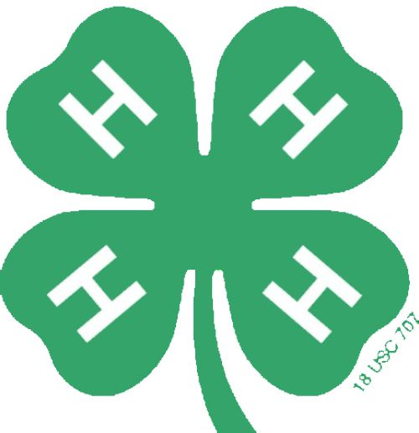
Performance Time:______________

Brown County 4-H Creative Arts Festival
Lip Sync Judging Sheet

Title:______________________________________________________________________________

Author:____________________________________________________________________________

Participant(s):______________________________________________________________________

4-H Club:__________________________________________________________________________

Criteria | Rating  1 . . . 2 . . . 3 . . . 4 . . . 5  Fair Excellent
1. Synchronization Between Music and Performer(s)

2. Appearance (use of costumes and/or props)

3. Stage Presence (facial expressions, gestures)

4. Choreography

5. Preparedness of Performer(s)

6. Overall Creativity

7. Crowd Appeal and Audience Response

8. Energy and Enthusiasm of Performer(s)

Total Score:

Comments:

Ribbon (circle one): Blue Red

