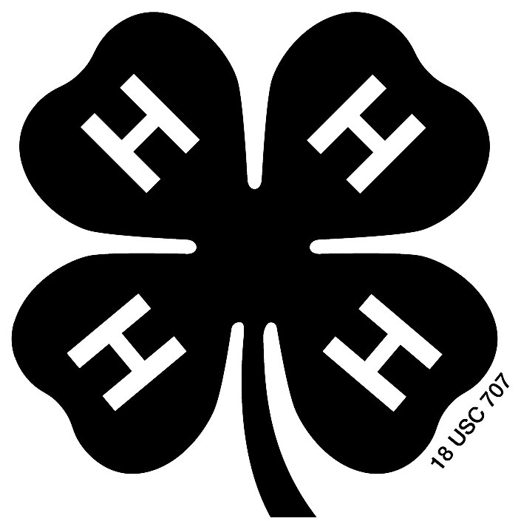
Brown County 4-H Creative Arts Festival
Music and Movement Guidelines

The four Music and Movement categories are as follows:
Instrumental
Vocal
Dance
Lip Sync
Novelty (combination of any 2 of the above categories)

Register as an individual (one participant), duet (2 participants), or group (3 or more participants). Performance should be at least one minute and no more than 10 minutes.

At least half of the participants must be Brown County 4-H members. Only youth can be on stage during the performance. Adult leaders may assist with recorded music, lighting, sound effects, holding props, etc. from off stage. Adults may help move props on and off the stage between scenes or songs.

Individuals may perform in more than one music and movement performance. Performances may have participants from multiple 4-H clubs.

Instrumental, Vocal, Novelty, and Dance groups may use professionally recorded instrumental music, a recorded accompanist, or a live accompanist during the performance. Professional recorded vocal music is only allowed for dance and lip sync selections. A Bluetooth speaker will be provided for participants to use.

Appropriate music and songs must be chosen.

Presentations already prepared for use in solo ensemble or other programs are acceptable.

Props, costumes, and makeup may be used to enhance the quality of the performance. Modest attire or costuming must be selected. Participants should dress appropriately for a performance.

A piano, one microphone, and music stands will be provided for use. Keyboard, extension cords, amps, and other instruments or equipment must be brought by participants. There is not a mixing table available to use.

After the performance, all participants will meet with the judges for a verbal evaluation. They will also receive a written evaluation at the conclusion of the event.

Blue (1st place) or red (2nd place) ribbons will be awarded for all entries. Any number of blue or red ribbons can be presented overall for each Music and Movement category.

At the judges’ discretion, “Best of Category” and/or “Honorable Mention” and/or a Zittlow Award may be given.

