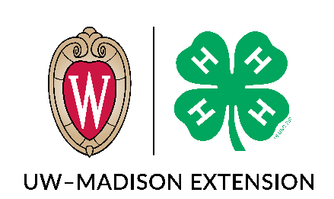
Wisconsin Key Award
Nominations Due May 1st, Applications Due June 1st
About the Key Award
As 4-H members, we make a commitment. A commitment to ourselves, and those around us. Our commitment is to four H’s – head, heart, hands, and health. These are the words that hundreds, or thousands, of 4-H members say – and work to live by. Each time we say the pledge, we are promising to give our all – not just for me, or my club, or my community – but also for the whole world.
As a way to recognize the 4-H members who truly embrace and live this commitment, Wisconsin has developed The Wisconsin Key Award: one of the highest honors awarded to top-notch 4-H members in their 9th-13th grade years. Young people who can say, in true 4-H honesty ways, that they have dedicated their heads, hearts, hands and health to their club, their community, their country and their world deserve recognition and honor.
To be eligible for this award, candidates must be in 9th grade or above and must have completed at least three years of 4-H and one year of youth leadership. Previous recipients of the award are not eligible to receive the award again.
Young people for this award can either SELF NOMINATE or BE NOMINATED BY an adult or older youth who can vouch for their 4-H commitment. Often, young people don’t see the good they do – and the nomination process can be a way of sharing with young people they are not only seen, but commended.
What does it mean to live the four H’s in Key Award language? Check out the video below:
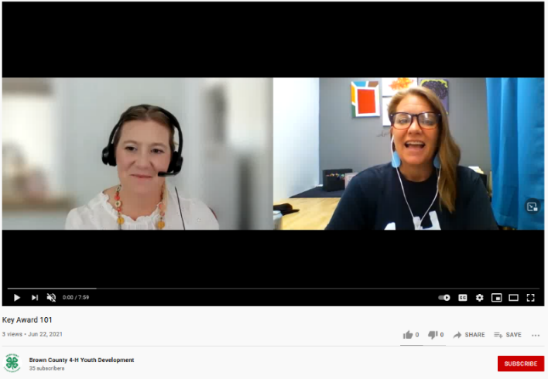

https://youtu.be/47modeFkJ00

How to: Self-Nomination or Nomination of Others
Self-Nomination: Does this relate to you? Fill out the Key Leadership Award Nomination Form and tell us about yourself.
Nomination of Others: Do you know of someone that deserved this honor? Fill out the Key Leadership Award Nomination Form, and we will reach out to them. You can share your name or remain anonymous.
Key Leadership Award Nomination Form

This form must be submitted by May 1st.

4-H Member Nominated: _______________________________________________________________

Member’s Primary 4-H Club: _________ ___________________

Name of Nominating 4-H Leader:

Phone Number of Nominating 4-H Leader:

Email Address of Nominating Leader:

Do you wish to remain anonymous?

After the nomination has been made, eligible youth will be notified. Nominees will be requested to submit an essay about how they have used their heads, hands, heart and health and lived the 4-H pledge.

Return this form via email or mail by May 1st to:

4h@browncountywi.gov
or
Extension Brown County 4-H
STEM Innovation Center
2019 Technology Way, Room #113
Green Bay, WI 54311

Key Leadership Award Application

4-H Members must be completing their junior or senior year of high school the year they apply. This application must be completed by the 4-H member.

Return this form to the Brown County 4-H Office by June 1st. If you did not receive a reply via email or phone call in a timely manner to confirm your application was received by the 4-H office, please follow up to confirm.

Youth Name:
Youth Club/Group:
In 1-2 pages, answer the following questions:
- Tell us about yourself. Include how long you have been in 4-H, your projects, your leadership role(s) in your club, your favorite things you have learned, seen, or done.

- How has being a member of 4-H helped you learn, live, and grow as a person? What do the 4 H’s mean to you, and how have you lived out the pledge in your 4-H club and beyond (both within and outside of 4-H)?

- How do you plan to take everything you learned in 4-H and use it, as you move into your next chapter of life?

OPTIONAL ATTACHMENT: If you would like to attach a resume of your time with 4-H (leadership roles, positions, projects, etc.), you may include it here. Please limit your resume to 1-2 pages.
What makes you the best candidate for a Wisconsin Key Award? This is the time to toot your own horn!

Return this form & attachments via email or mail by June 1^{st.} If you did not receive a reply via email or phone call in a timely manner to confirm your application was received by the 4-H office, please follow up to confirm.
4h@browncountywi.gov
or
Extension Brown County 4-H
STEM Innovation Center
2019 Technology Way, Room #113
Green Bay, WI 54311

