A3306
Exhibiting and Judging

V E G E T A B L E S
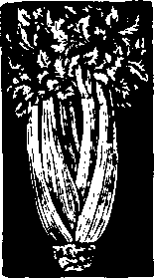

H.C. Harrison

A good vegetable display attracts attention–whether it in-terests the judge at a competition or catches the consumer’s eye at a roadside stand or in the grocery store.
Vegetables for any type of display should be carefully selected, prepared and exhibited. The characteristics of each vegetable that attract the judge and make for a win-ning exhibit are the same characteristics that make vegetables attractive to consumers.
While this publication is directed to the fair exhibitor, the information within also applies to vegetable vendors.

Why Exhibit?
Displaying your crops is one way you can take pride in hav-ing produced top quality vegetables. While gardening is a fun, relaxing way for the entire family to spend time togeth-er and save money by growing fresh produce, you can in-crease the enjoyment you get from gardening by trying to grow new, different kinds of crops. Your work–those top-notch vegetables–attracts attention. Take pride in your ac-complishment!

Growing the Vegetables
Selecting and preparing vegetables for display is much easier if you plan. Begin planning early in the year so you can get the type and quantity of seed you need. Pay special attention to planting dates, which variety you select, when and how much to fertilize, spacing and thinning of plants, controlling insects, weeds and diseases, and harvest dates.
Selecting plant varieties is important to growing quality vegetables. Select F1 hybrids and disease-resistant cultivars to avoid many disease problems in your garden. Frequently, hybrid cultivars are more vigorous, produce larger yields of
higher quality produce, and have greater disease resistance than many non-hybrid varieties.
For more information on planning and planting a vegetable garden, ask your county Extension agent for available gardening bulletins. The more popular bulletins on this top-ic include Vegetable Cultivars and Planting Guide for Wis-consin Gardens (A1653), Disease-Resistant Vegetables for the Home Garden (A3110), Managing Insects in the Home Vegetable Garden (A2088), The Vegetable Garden (A1989), and Crowing Vegetables at Home–Questions and Answers (A2801).

Planning for Quality and Quantity
Having enough vegetables for exhibition requires careful at-tention to planting dates, because this determines the harvest date. Vegetables that are immature or overripe are of little value at show time.
To determine the right planting date, check the seed catalog or packet for the approximate number of days required from planting to harvest. Then, starting from the opening date of the fair, count back that number of days on the calendar.
Mark this date as the targeted planting date. Also remember that when you plant depends on the hardiness of the veget-able, the days to maturity of a particular variety, and the climate in your area.
In addition, you should probably make two other plant-ings–one earlier and one a bit later–to allow for variations in the weather that can aid or hinder plant growth. You should also plant enough of each of vegetable so you can be choosy about which vegetables you want to show in order to prepare a top-notch exhibit.

1

Harvest more vegetables than you actually need for your ex-hibit to ensure a good selection. And take along a few extra vegetables to the exhibit location in case some of your ex-hibit vegetables are damaged in transit.
To know when to harvest your vegetables, check Harvesting Vegetables from the Home Garden (A2727).

Exhibit Requirements
When you are preparing vegetables for fair competition, be sure that the vegetables meet all premium list requirements. Read and follow the exhibit rules and regulations carefully. Never assume that last years rules apply this year, because rules may change from year to year
Exhibit requirements normally specify the class or kind of vegetables you can show; the number of specimens; the type, shape or size of containers; the size, shape, color and stage of maturity of individual vegetables; and whether the exhibit is to be an individual one or part of a larger display. The exhibit rules also give the time the exhibit must be ready for judging.
Vegetables are usually exhibited on plates, in a group display or as a market basketful. For a plate exhibit or a group display, the numbers of specimens usually required for each vegetable are listed below.

Required Numbers of Individual Vegetables*
1 SPECIMEN

12 SPECIMENS

Bean, green (pods) Onion, set
Bean, lima (pods) Pea (pods)
Bean, wax (pods) Pepper, small-fruited (chili,
Herbs (stems or branches) cherry, etc.)
Okra Shallot
Onion, green Tomato, small-fruited

*It is the superintendent’s responsibility to disqualify entries for the wrong numbers of specific vegetables, not the judge's.

Characteristics of a Good Vegetable Display
When you select vegetables for an exhibit, remember that a judge will evaluate them on the basis of quality, general con-dition, freedom from injury and uniformity. Characteristics that make vegetables attractive to a judge are similar to
what attracts you to buy them.

Quality
It’s important to know what judges look for in terms of quality in vegetables. Generally, quality is indicated by a vegetable’s color, size, shape and stage of development.
Many exhibitors believe that they need huge vegetables to have a winning vegetable entry. Although large size is im-portant in a few classes–such as heaviest cabbage, largest

Broccoli (head) Cabbage Cauliflower
Chinese cabbage (head) Eggplant
Greens (1 plan-collard, endive, escarole, kale, mustard, Swiss chard)
5 SPECIMENS
Horseradish (root) Lettuce (1 head or plant) Muskmelon
Pumpkin Squash, winter Watermelon
pumpkin or biggest watermelon–large size is not empha-sized as much in most vegetable classes.
Color. Select vegetables that have a deep, clear, intense color. Avoid dull-colored specimens, or those that are deep colored because they are overripe. Experience will help you determine the best time to harvest a particular vegetable.
Marketable size. Vegetables should be a size that will sell well on the open market. So when you are deciding on

Asparagus (spears) Pepper, large-fruited (bell,
Beet banana, etc.) Popcorn
Carrot (ears)
Corn, sweet Potato, Irish, red
Cucumber, pickling Potato, Irish, white
Cucumber, slicing Potato, sweet
Kohlrabi Rhubarb (stalks)
Leek Squash, summer
Onion, large, dry Tomato, slicing
Parsnip Turnip

2
what vegetables to exhibit at the fair, think in terms of the sizes most consumers want at the supermarket. Consumers generally prefer average-sized vegetables over extremely large or small vegetables.
Trueness to type or shape. All vegetables should be as true as possible to the type or shape of the variety. For example, an elongated beet is not typical of the cultivar ‘Detroit Dark Red’ even though some elongated beets may develop from ‘Detroit Dark Red’ seed.

Maturity or stage of development. Vegetables should be in prime condition for eating at the time of judg-



ing. In case of a late season or early fair, immature specimens are usually accepted.
Judges should use a higher set of standards for judging green tomatoes and other immature vegetables such as win-ter squash if both mature and immature specimens are ex-hibited in the same class.

Condition
The condition of exhibits is important and includes how fresh and clean the vegetables are, and how they are trimmed.
Freshness. Many vegetables are perishable, so you should take measures to prevent shriveling. Vegetables which shrivel readily are young snap beans, beets, broccoli, carrots, celery, chard, Chinese cabbage, pickling cucumbers, endive, kohlrabi, lettuce, green onions, parsley, parsnip, radish, rhubarb and spinach.
Harvest these vegetables as close to exhibit time as possible and refrigerate them in plastic containers or other closed containers until shortly before exhibit time.

Cleanliness. Only enter vegetables that are clean and bright in appearance. Dirty vegetables give the judge a bad impression–they indicate that the exhibitor was not really interested in preparing an attractive, first-rate display.
Sometimes you can clean vegetables by washing them, while in other cases, wiping them with a soft, clean cloth or brushing them lightly with a soft brush is sufficient.
Trimming. Vegetables should be neatly and properly trimmed, much like market produce.

Freedom from Injury
All vegetables should be free of insects and diseases, as well as mechanical injuries.
Mechanical injuries–such as those caused by weather or rough treatment during harvest–downgrade an exhibit. For example, you should not show root crops that have been in-jured while digging, or squash with stems torn off.
To avoid any injury to exhibit vegetables when you’re transporting them to the fair, pack the vegetables carefully in cloth or paper. Place the wrapped vegetables in bushel baskets or boxes, using a lot of crumpled paper between layers. Also take along extra vegetables for each exhibit, in case something happens to the vegetables chosen for entry in the exhibition.

Uniformity
“Uniformity” means that each vegetable on a plate or each vegetable within a display is of similar size, color, stage of maturity, shape and type. Judges place considerable impor-tance on the uniformity of vegetables exhibited. The larger your supply of vegetables, the better chance you have to choose vegetables that are uniform in every respect.
Size. Choose the size that is desirable on the market. Remember, the biggest vegetable is usually not the best–for many vegetables, unusual size often indicates poor quality.
You should also keep the sizes of like vegetables similar. Do not place four large tomatoes and one small tomato on a plate. Instead, select five medium-sized tomatoes. Also, try to arrange the tomatoes on the plate so the largest and smallest ones are not next to each other.

Shape. Select the shape most typical of that vegetable variety.
Color. Color should be uniform for all vegetables of a vari-ety. Intense, deep-colored specimens are usually preferred.
Maturity. Vegetables exhibited should all be at the same stage of maturity.
Type. Vegetables should all be the same variety.
Suggested Scorecard for Judging Vegetables
A. QUALITY 40 points
Marketable size | 10
Characteristic color | 10
Typical shape | 10
Stage of development or maturity | 10
B. CONDITION | 20 points
Cleanliness | 7
Proper trimming | 7
Freshness | 6
C. FREEDOM FROM INJURY | 20 points
Mechanical | 10
Pests | 10
D. UNIFORMITY | 20 points
Shape | 4
Size | 4
Color | 4
Type or variety | 4
Stage or maturity | 4

3

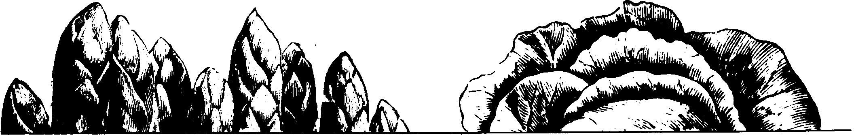

Suggestions for Selecting Exhibit Vegetables
The following are suggestions to help you select vegetables for an exhibit or competition. These recommendations should supplement the specific rules established by your show committee.

Asparagus
–straight, dark green spears with tight scales
–free of rust, insect injury or other blemishes
–spears trimmed to 7 or 8 inches
–clean by washing or wiping with soft cloth
–extremely perishable

Bean, Lima
In pods
–pods well-filled, bright green, tender and fresh
–trim stems to 1/4 inch
–clean by wiping with soft dry cloth; do not wash
Shelled
–shell as close to exhibit time as possible
–avoid mixing young green seeds and overmature white seeds

Bean, Snap and Other (Romano, Green, French Horticultural, Wax, Yellow and Purple)
–pods tender, stringless, brittle, with seeds in immature stage
–free of dirt, rust, blemishes or other imperfections
–trim stems to 1/4 inch
–clean by wiping with soft dry cloth; do not wash

Beet
–smooth, free of side roots and blemishes
–medium- to small-sized beets preferred (1½ to 2 inches in diameter for small, whole beets and 2½ to 3 inches for slicing or dicing beets)
–when cut, flesh should be firm, crisp and fine-grained
–can be displayed with top leaves (bunching beets), or cut down to ½ to 1½ inch; tap root should be left on
–clean by soaking and washing in cold water

Broccoli
–stalk and head at least 6 inches long; firm, tender and crisp with good color
–buds tightly closed
–center head at least 4 inches in diameter or group of 4 side shoots tied neatly together
–leaves removed below head
–clean by dipping in cold water

Brussels Sprouts
–uniform, medium in size
–firm, well shaped, compact
–dark green color
–trim stem to ¼ inch
–rinse thoroughly

Cabbage
–head solid and heavy for size
–free of blemishes and insect damage
–stem evenly trimmed at base of the last leaves left on the head
–trim all but 2 or 3 outer leaves
–clean by wiping with dry or moist cloth (if necessary), or rinse thoroughly

Carrot
–specimens straight, deep orange color, smooth skin
–free of cracks greening or side roots
–tops trimmed to ½ to 1 inch unless premium list specifies carrots with tops; do not remove tap root
–length: short varieties–2¼ to 2½ inches; half-long varieties–5 to 7 inches; long varieties–7½ inches or more; do not mix varieties
–clean by washing; do not scrub

Cauliflower
–heads pure white, solid, uniform, with 4 to 6 protective leaves attached
–protective leaves trimmed to 1 inch above the head to expose curd
–curd should be compact, deep, firm and at least 4 inches in diameter
–stem cut off ½ to 1 inch below bottom leaf
–clean by wiping with dry cloth or brushing if necessary

Celeriac (root celery)
–roots fully developed
–trim all branch roots
–remove top squarely to length of 1 to 2 inches
–wash thoroughly

Celery
–large plant with many crisp stalks
–remove small outside stalks, suckers or leaves; trim stem neatly
–remove excess tops squarely at 10 to 12 inches unless premium list specifies otherwise
–wash thoroughly but gently

4

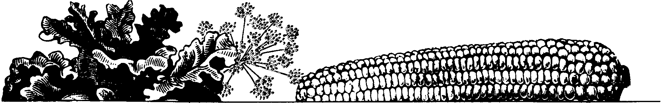

Chard
–well-developed plants or individual leaves if specified in premium list
–remove roots neatly
–stalks may be red or green depending on variety
–rinse thoroughly but carefully
–perishable

Endive
–specimen stout, crisp, tender
–well-blanched heart
–remove older, tougher outer leaves and roots
–clean by rinsing
–perishable

Herbs

Chinese Cabbage –leaves fresh and tender; free of blemishes, bruises, and

–firm, fully developed heads
–remove loose outer leaves to first tightly wrapped green

leaves
–remove roots below base of leaf petioles
–clean by rinsing
–perishable

Collards
–leave 4 to 5 wrapper leaves to protect plant
–dark green color
–remove all dead or damaged leaves
–clean by rinsing
–perishable
insect and disease damage
–trim stems evenly
–clean by washing (if necessary)
–perishable

Kale
–plant with heavy, large, dark green, closely set, well-curled foliage; or, if specified, individual leaves 8 to 10 inches long
–remove roots
–rinse thoroughly
–perishable

Kohlrabi

Corn, Sweet –specimens 2 to 4 inches in diameter, tender with good

–ears fresh and well-filled from tips to butt ends
–kernels in milk stage and arranged in closely spaced rows
–remove “flag” leaves but do not remove husks unless premium list specifies; if husking, do so carefully and remove all silk
–trim stem evenly
–clean by wiping with dry cloth
–extremely perishable if husked

Cucumber
–straight, deep green, firm, with blunt ends
–trim stem to ¼ to ½ inch
–length: burpless cucumber–10 to 12 inches; slicing cucumber–6 to 8 inches; dill pickles–3 to 4 inches; sweet pickles–l½ to 2½ inches
–do not wax
–clean by wiping with a soft, dry cloth or moist cloth if necessary

Dill (seed heads or seeds; for leaves see Herbs)
–for pickling–umbels in full bloom; for cooking–seeds light brown on umbels
–large plant with symmetrical umbels
–trim stem 3 inches below the spot where umbels connect

Eggplant
–specimens firm, shiny, with uniform, deep color
–small blossom scar and a fresh green calyx
–trim stem to 1 inch
–clean by wiping with soft, dry cloth or moist cloth
color
–leave 4 to 6 crown leaves, trim to ½ inch
–cut off tap root ½ inch below the enlarged stem
–clean by brushing or wiping with dry cloth

Leek
–specimen long, thick and firm, with pure white well-balanced stems
–trim tops and roots evenly
–clean by wiping with damp cloth or rinse carefully

Lettuce (Leaf, Butterhead and Cos)
–well-developed compact plants with firm, crisp, medium–sized heads
–remove older, loose, discolored outer leaves.
–cut stem squarely at base of head
–wash thoroughly
–perishable

Muskmelon
–evenly netted and free of decay spots, defects or cracks
–smooth stem, indicating harvest at “full-slip” stage
–clean by brushing off soil when dry

Mustard
–cut entire plant just below crown
–remove discolored or injured leaves
–wash thoroughly
–perishable

5



Okra
–small, straight pods that are fresh, bright green and less than 3 inches long
–harvest before pods become woody and fibrous, and seeds harden
–leave ½-inch stem
–clean by wiping with dry or moist cloth, or by brushing

Onion, Dry
–firm, mature, well-shaped bulbs, at least 2 inches in diameter
–avoid double and split bulbs, and those with soft necks
–remove loose outer scales to first tight, dry, fully colored scale
–trim top to 1 inch; trim roots at base of bulb
–clean by brushing specimens while dry; do not wash

Onion, Green Bunching
–select straight plants that are 3/8 to ½ inch in diameter
–remove older outer leaves
–trim tops to 7 to 8 inches and roots to ½ inch
–clean by rinsing

Onion, Immature Large
–fully developed but uncolored
–remove 1 or 2 outer leaves
–cut tops and roots at base of bulb to 1 inch
–clean by rinsing

Parsley
–need one bunch for an exhibit–10 to 20 leaves
–vigorous, dark green, curling leaves
–trim stems evenly
–bunch length should be 8 to 10 inches
–wash thoroughly
–perishable

Parsnip
–roots solid, smooth, well-shaped and 2 to 2½ inches in diameter
–tapered evenly with no side roots
–skin a light, creamy yellow color
–trim tops to 1 inch; leave tap root on
–clean by soaking in water to remove dirt; do not scrub

Pea
Regular cultivars
–well-developed green pods; leave in pod or shell as specified in premium list
–pods should have ½-inch stems
–do not wash
Edible-pod cultivars
–well-developed green pods; leave in pod

6
–pods should have ½-inch stems
–do not wash
Chinese or snow cultivars
–pods tender, green, seeds in immature stage; leave in pod
–pods should have ½-inch stems
–do not wash
–do not mix cultivars

Pepper, Bell
–firm, thick-fleshed with deep color
–all should have the same number of lobes
–trim stems to ¼ to ½ inch
–clean by wiping with soft, dry cloth

Pepper (Other than Bell)
–length, shape and color should be typical of the variety
–trim stems to ½ to ¾ inch
–clean by wiping with soft, dry cloth

Potato
–fully mature clean, free of insect or disease damage injury, cracks, sunburn or greening
–after tubers have dried, clean by brushing lightly to remove soil or wash carefully
–do not mix varieties

P u m p k i n
–good color, thick-fleshed and heavy in weight for size of specimen
–free of blemishes and dirt
–trim stem to 2 inches
–clean by wiping and polishing with a dry cloth, or wash carefully

Radish
–smooth, firm, medium-sized
–remove tops ½ to 1 inch above crown
–trim main root to 1 inch
–wash thoroughly

Rhubarb
–stalks at least 10 inches long and at least 1 inch across at the middle of the stalk
–skin smooth and well-colored
–trim leaves to 1 or 2 inches; trim base evenly
–clean by wiping with dry cloth or washing if necessary
–do not mix red and green varieties

Rutabaga
–3½ to 5 inches in diameter; smooth, free from insect damage
–remove tops ¼ to ½ inch above the crown
–trim tap root to ¼ inch
–wash carefully



S a l s i f y
–straight, smooth, firm, and at least 6 inches long and 1 to 1½ inches in diameter at top
–remove tops ½ to 1 inch above crown
–remove rootlets and side roots
–trim tap root to 1 inch
–wash carefully

Spinach
–leaves large, broad, thick and fresh
–exhibit 6 to 8 leaves or as specified in premium list
–cut squarely at base of petiole
–clean by rinsing
–perishable

Squash, Summer
–soft rind (immature) and at prime eating stage
–avoid overmature, bruised or misshapen specimens
–elongated varieties–4 to 8 inches long scallop varieties–3 to 5 inches in diameter
–leave 1 inch of evenly trimmed stem attached
–clean by wiping with soft, dry cloth, do not wash

Squash, Winter
–outer rind hard and firm, full color
–avoid immature, cracked or split specimens
–leave 1 to 2 inches of stem attached
–clean by brushing or wiping with soft, dry cloth

Tomato
–firm, and free of cracks blossom–end rot, insect, disease or mechanical damage
–ripe tomatoes should be in prime condition for slicing; avoid overripe fruit
–deep characteristic color, shape and size
–green tomatoes should be entirely green with no red visible
–do not exhibit red and green tomatoes on the same plate
–display with or without stems
–clean by wiping with moist cloth

Turnip
–roots at least 1½ to 2½ inches in diameter
–trim tops to 1 inch; leave tap root 2 to 3 inches long
–clean by washing

Watermelon
–typical of variety in shape and color
–mature but not overripe; bright or velvety appearance
–ground spot should be yellowish in color and not white or pale green
–stem 1 inch long
–clean by wiping with moist cloth

There are a few things that you should make sure that you do not do when you exhibit vegetables. Here’s a checklist.

- Don’t show vegetables that are injured or dirty.
- Don’t show vegetables that are not uniform in size, shape, color, maturity and type.
- Don’t exhibit overripe vegetables.
- Don’t exhibit more than one kind of large vegetable in a box, if possible.
- Don’t exhibit leafy vegetables unless it is absolutely necessary.
- Don’t use filler material.
- Don’t peel onions. Harvest the bulbs 2 to 3 weeks before showing so they will be well ripened and dirty outer scales will be dry and easily removed–this makes peeling unnecessary.
- Don’t cut windows in the husks of sweet corn.
- Don’t exhibit mature summer squash.
- Don’t exhibit the biggest vegetables you have, because unusual size frequently indicates poor quality due to over-maturity.
- Don’t include gourds, peanuts, Indian corn and omamen-tals in vegetable exhibits.
- Don’t exhibit specimens of 'Turks Turbin'–it is a gourd.
- Don’t count different varieties of one vegetable as dif-ferent kinds of vegetables.
- Don’t forget to attractively arrange your vegetable display.
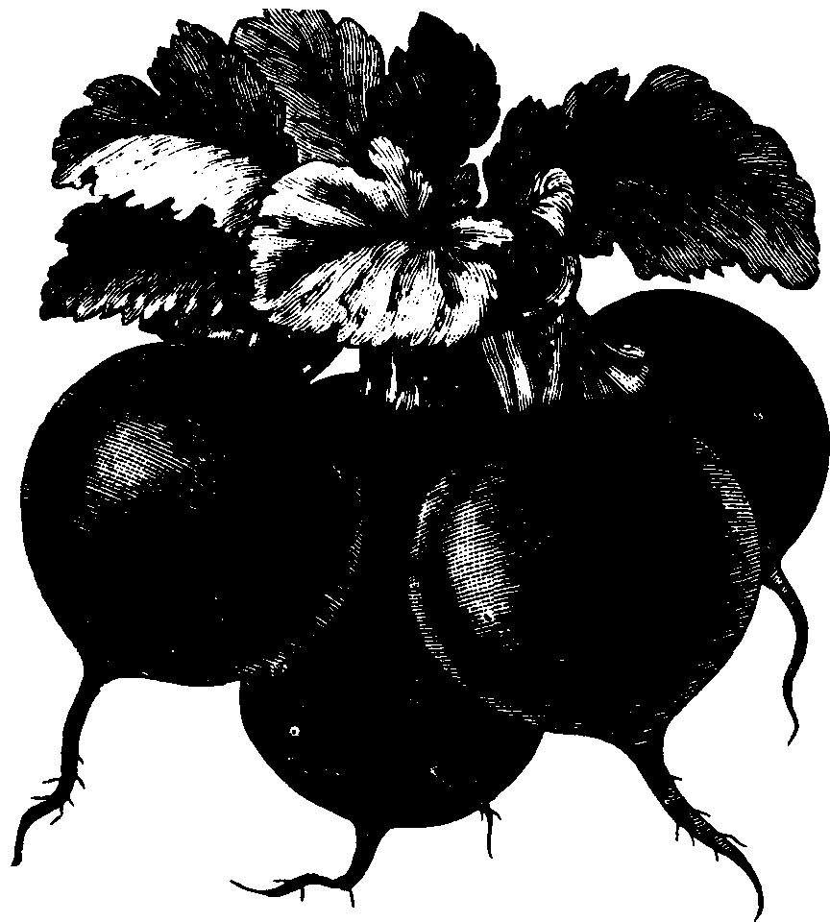

7

This publication replaces Circular 4-H 160-Selecting and Preparing Vegetables for Display.


University of Wisconsin-Extension, Cooperative Extension Service, Charles F. Koval, director, in cooperation with the
U.S. Department of Agriculture and Wisconsin counties, publishes this infor-mation to further the purpose of the May 8 and June 30, 1914 Acts of Con-gress; and provides equal opportunities in employment and programming including Title IX requirements.
Produced by the Department of Agricultural Journalism, University of Wisconsin-Madison.
A3306 EXHIBITING AND JUDGING VEGETABLES
30¢ I-03-85-5M-H
This publication is available from your Wisconsin county Extension office or from:
Agricultural Bulletin Building 1535 Observatory Drive
Madison, Wisconsin 53706
Phone 608-262-3346
Editors, before publicizing, contact the Agricultural Bulletin Building to determine availability.
Helen C. Harrison is assistant professor of horticulture, College of Agricultural and Life Sciences, University of Wisconsin-Madison and Cooperative Extension Service, University of Wisconsin-Extension.

