FRIEND OF 4-H AWARD NOMINATION

Year:

The Brown County Friend of 4-H Award is sponsored by the Brown County 4-H Leaders Association. The recipient of this award is a person or organization who supports the overall 4-H program and has an excellent understanding of the purpose of 4-H.

Nominations can be made by Brown County 4-H Leaders or Members. Nominators may be asked to present the award.
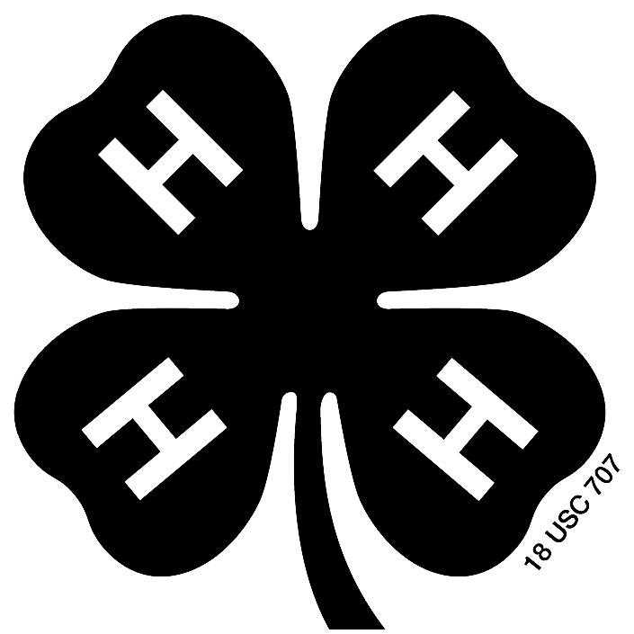

Nominee

Group or Firm Represented

How has this person helped Brown County 4-H efforts? Be specific and supply examples.

Nominating Club/Person Date

Please return this form to the 4-H Office by August 31st.
Email: 4h@browncountywi.gov
Mail: Brown County 4-H Office
2019 Technology Way, Rm 113
Green Bay, WI 54311

